

Year 12 Chemistry
Semester One, 2005

Name: ......................................................................................................................................................

Teacher: .......................................................................................................................................................

Time allowed for this paper
Reading time before commencing work: Ten minutes
Working time for paper: Three hours

Materials required/recommended for this paper
To be provided by the supervisor
This Question/Answer Booklet
Separate Multiple Choice Answer Sheet
Chemistry Data Sheet

To be provided by the candidate
Standard Items: Pens, pencils, eraser or correction fluid, ruler
Special Items: Calculators satisfying the conditions set by the Curriculum Council for this
subject. (2 x HP graphic and any number of non-programmable scientific calculators.

Important note to candidates
No other items may be taken into the examination room. It is your responsibility to ensure that you
do not have any unauthorised notes or other items of a non-personal nature in the examination
room. If you have any unauthorised material with you, hand it to the supervisor before reading any
further.

Structure of this paper
Part | Format |  | No. of  Questions  Set | Number of Questions to be Attempted | Marks  available | Suggested  working time  (minutes)
1 | Multiple choice |  | 30 | All | 60 (30%) | 55
2 | Short answers |  | 12 | All | 70 (35%) | 60
3 | Calculations |  | 5 | All | 50 (25%) | 45
4 | Extended answers |  | 2 | 1 | 20 (10%) | 20
Total marks 200 (100%)

Instructions to candidates

1. The rules for the conduct of Tertiary Entrance Examinations are detailed in the booklet TEE
Handbook. Sitting this examination implies that you agree to abide by these rules.

2. Answer the questions according to the following instructions:

Part 1 Answer all questions on the separate Multiple Choice Answer Sheet.
Use a ball point or ink pen.

If you consider that two or more of the alternative responses are
correct, choose the one you think is best. If you think you know an
answer, mark it even if you are not certain you are correct. Marks will
not be deducted for incorrect answers.

Feel free to write or do working on the question paper; many students who score high marks in the Multiple Choice Section do this.

Parts 2, 3 and 4 Write your answers in the spaces provided in this Question/Answer
Booklet. A blue or black ball point or ink pen should be used.

Questions containing specific instructions to show working should be
answered with a complete, logical, clear sequence of reasoning showing
how the final answer was arrived at; correct answers for such questions which do not show working will not be awarded full marks.

3. The examiners recommend that you spend your reading time mainly reading the instructions
to candidates and Parts 2, 3 and 4.

4. Chemical equations

For full marks, chemical equations should refer only to those species consumed in the
reaction and the new species produced. These species may be ions [for example Ag⁺ _{(aq)}], molecules [for example NH_{3(g)}, NH_{3(aq)}, CH₃COOH_{(l)}, CH₃COOH_{(aq)}] or solids [for example BaSO_{4(s)}, Cu_{(s)}, Na₂CO_{3(s)}].

PART 1 (60 marks)

Answer ALL questions in Part 1 on the Separate Multiple Choice Answer Sheet provided, using
a pen only. Each question in this part is worth 2 marks.

1. Element X has the outer shell electron configuration s²p¹. Element Y has the outer shell electron configuration s²p³. The most likely formula of the compound formed by X and Y is which of the following?

(a) XY
(b) XY₂
(c) X₂Y
(d) X₂Y₃

2. Which of the following rows contains three correct formulae for the named ions?

 | dichromate ion | dihydrogenphosphate  ion | oxalate ion
(a) | CrO₂- | H(PO4)₂- | O2-
(b) | Cr₂O₇² ⁻ | H2PO4- | C₂O₄2-
(c) | Cr₂O₃²- | HPO42- | O22-
(d) | CrO22- | HPO32- | HCOO-

3. An element has the electronic configuration 1s2 2s2 2p6 3s2 3p5 .
In which group and period of the Periodic Table is the element located?

(a) Group III, period 4
(b) Group V, period 4
(c) Group IV, period 1
(d) Group VII, period 3

4. Which one of the following has only dispersion forces between its molecules in the liquid phase?

(a) CO2
(b) NH3
(c) C2H5OH
(d) H2O

5. Covalent bonds are most commonly found between

(a) elements with low first ionization energies
(b) elements with a large difference in first ionization energies
(c) elements with similar but relatively high first ionization energies
(d) gaseous and solid elements

6. The unusual electrical conductivity of graphite (a form of pure carbon) is best explained by which of the following?

(a) Carbon atoms are free to move between the layers in graphite, carrying their charge with them.

(b) Carbon atoms form three covalent bonds with neighbouring atoms in graphite, leaving one valence electron for conductivity.

(c) Carbon atoms in graphite form charged molecules which move under the influence of an applied electrical field.

(d) Carbon has only dispersion forces between atoms in graphite, so the four valence electrons are free to move throughout the structure.

7. Which of the following substances have both covalent and ionic bonding within them?

(a) CsF _{(s)}
(b) C2H5Cl _{(l)}
(c) Ca3(PO4)2 _{(s)}
(d) HF _{(g)}

8. A 10.0 L sample of air at 25.0ºC weighing 11.80 g was collected from a busy city intersection, and was found to contain 0.230 mg of lead. The concentration of lead in the air is which of the following?

(a) 0.0230 ppm (parts per million)

(b) 1.18 ppm

(c) 19.5 ppm

(d) 51.3 ppm

9. 20.0 mL of 0.100 mol L-1 calcium chloride solution is added to 80.0 mL of 0.0500 mol L-1 silver nitrate solution.
The concentrations of ions in the final 100.0 mL of solution is correctly shown by which of the following?

 | [Ca2+_{(aq)}] | [NO3-_{(aq)}] | [Ag+_{(aq)}]
(a) | 1.00 x 10-2 mol L-1 | 2.00 x 10-2 mol L-1 | 2.00 x 10⁻² mol L⁻¹
(b) | 2.00 x 10-2 mol L-1 | 4.00 x 10-2 mol L-1 | zero moles per litre
(c) | 2.00 x 10-2 mol L-1 | 8.00 x 10-2 mol L-1 | 1.00 x 10⁻² mol L⁻¹
(d) | 4.00 x 10-2 mol L-1 | 8.00 x 10-2 mol L-1 | zero moles per litre

10. Which of the following molecules possess a molecular dipole?
1 CH₄ 4 CO₂
2 CF₄ 5 NH₃
3 CO 6 HCl

(a) 1,2,5 and 6
(b) 2,3,5 and 6
(c) 2,3,4,5 and 6
(d) 3,5 and 6

11. Ammonium chloride solution is

(a) acidic because chloride ions react with water to give HCl
(b) basic because ammonium ions react with water to give OH⁻
(c) basic because it contains ammonia which is a base
(d) acidic because of the reaction between ammonium ions and water

12. Solutions of lithium carbonate, sodium chloride and ammonium sulfate have their pH tested.
Which of the following is the correct classification from the test?

Li2CO3_{(aq)} NaCl_{(aq)} (NH4)2SO4_{(aq)}

(a) acidic neutral basic
(b) basic neutral acidic
(c) neutral acidic basic
(d) neutral acidic neutral

13. In which of the following equations is nitric acid acting as an oxidising agent?

1) P₄O₁₀ + 4HNO₃ → 4HPO₃ + 2N₂O₅

2) 6Fe²⁺ + 8HNO₃ → 6Fe³⁺ + 2NO + 4H₂O + 6NO₃⁻

3) CO₃²⁻ + 2HNO₃ → CO₂ + H₂O + 2NO₃⁻
4) Cu + 4HNO₃ → Cu²⁺ + 2NO₃⁻ + 2H₂O + 2NO₂
(a) 1 and 3
(b) 2 and 4
(c) 1,2 and 4
(d) 1,2,3 and 4

14. Which of the following best describes the shape and polarity of a molecule whose formula is CF4 ?

(a) tetrahedral, non polar
(b) pyramidal, polar
(c) pyramidal, non polar
(d) tetrahedral, polar

15. Silicon dioxide has a much higher melting point than carbon dioxide. Which of the following best explains this difference?

(a) Silicon dioxide is a larger molecule than carbon dioxide, so the dispersion forces between its molecules are greater than those between carbon dioxide molecules.

(b) The double bonds within silicon dioxide molecules are stronger than the double bonds within carbon dioxide molecules.

(c) Silicon atoms in silicon dioxide are each bonded to four oxygen atoms to produce an extended covalent bonding arrangement, whereas carbon dioxide forms discrete molecules.

(d) Silicon dioxide molecules are polar and have stronger dipole - dipole interactions, whereas carbon dioxide molecules are non-polar and have only weak dispersion forces between them.

16. Which of the following pairs of reagents would produce a white precipitate. Assume all concentrations to be 0.100 mol L⁻¹.

(a) Iron (III) nitrate and sodium hydroxide solutions,
(b) Calcium chloride and potassium carbonate solutions,
(c) Barium chloride and potassium hydroxide solutions,
(d) Copper (II) chloride and ammonium carbonate solutions.

17. Which of the following statements about oxidising and reducing agents is false?

(a) Hydrogen peroxide solution is capable of spontaneous self oxidation - reduction.
(b) Group I metals are good reducing agents.
(c) Acidified potassium permanganate solution can oxidise oxalic acid solution to carbon
dioxide and water.
(d) Copper metal will react with nitric acid solution.

18. Lanthanum carbonate is insoluble, and precipitated according to the equation

_{(s)}

A solution containing 0.600 mol of lanthanum nitrate is added to a solution containing 0.600 mol of sodium carbonate. How much lanthanum carbonate is precipitated?

(a) 0.200 mol
(b) 0.300 mol
(c) 0.600 mol
(d) 1.20 mol

19. Health Department analysis of recently imported Dog Food indicated the presence of a new component which contained 42.1% oxygen. Which of the following exotic compounds would fit this analysis? [La has an atomic number of 57 and W has an atomic number of 74]

(a) BONe
(b) LaSSiO
(c) PO₂CH
(d) WO₂F
20. Which of the following reactions represent disproportionation (self oxidation - reduction)?

I 2CrO₄²⁻_{(aq)} + H⁺_{(aq)} → Cr₂O₇²⁻_{(aq)} + OH⁻_{(aq)}
II 3I_{2(s)} + 6OH⁻_{(aq)} → 5I⁻_{(aq)} + IO₃⁻_{(aq)} + 3H₂O_{(l)}
III Zn(s) + 2H⁺_{(aq)} → Zn²⁺_{(aq)} + H_{2(g)}
IV 2Cu⁺_{(aq)} → Cu_{(s)} + Cu²⁺_{(aq)}

(a) I only
(b) II and IV only
(c) III only
(d) IV only

21. A student is given samples of 5 white solids, PbCO₃, K₂CO₃, PbCl₂, Ca(NO₃)₂, and AgNO₃ labelled at random A, B, C, D, and E.

Substance A is soluble in water and liberates a gas when dilute HCl is added.
Substance B is soluble in water and its solution produces a precipitate when NaCl is added.
Substance C is insoluble in water and reacts with dilute HCl, forming bubbles of gas.
Substance D when dissolved in water produces a white precipitate when reacted with a solution of substance A.
What is substance E?

(a) AgNO₃
(b) PbCl₂
(c) K₂CO₃
(d) PbCO₃

22. In which one of the following species is the oxidation number of manganese lower than it is in
the other three compounds?

(a) K2MnO4
(b) Mn2O3
(c) NaMnO4
(d) MnO2

23. For the titration between dilute ethanoic acid (in a burette) and standardised sodium hydroxide
in a conical flask, which of the following procedures is incorrect?

(a) Prior to adding the acid to the burette, rinse the burette with distilled water and then a small portion of the acid solution.

(b) Pipette out 20.00 mL aliquots (portions) of the sodium hydroxide solution into three separate conical flasks which have each been rinsed with distilled water.

(c) Rinse the pipette with the standardised sodium hydroxide solution before transferring
the first aliquot to the conical flask.

(d) Add a few drops of methyl orange indicator to the acid in the burette.

24. An element reacts vigorously with cold water to produce hydrogen. It forms colourless ions and its salts are all soluble. Which of the following is the most likely identity of the element?

(a) Cu
(b) Fe
(c) K
(d) Mg

25. Which best describes how the periodic table is ordered?

(a) The acidities of the oxides
(b) The atomic numbers of the elements
(c) The ionisation energies of the elements
(d) The masses of the atoms

26. A student requires a solution of pH = 4 for an experiment.
Which of the following procedures will yield such a solution?

(a) Add 50 mL of a solution of pH = 2 to 50 mL of a solution of pH = 6.
(b) Add 95 mL of distilled water to 5 mL of 0.1 mol L⁻¹ HCl_{(aq).}
(c) Add 50 mL of 0.1 mol L⁻¹ NaOH_{(aq)} to 25 mL of 0.1 mol L⁻¹ HCl_{(aq).}
(d) Add 1.0 mL of 0.01 mol L⁻¹ HCl_{(aq)} to 99 mL of distilled water.

27. Which one of the following groups contains only oxides that would form acids when dissolved in water?

(a) MgO, CaO, Al₂O₃
(b) MgO, Cl₂O, PbO
(c) NO₂ , Na₂O, CO₂
(d) NO₂ , SO₂ , Cl₂O,

28. Which one of the following species cannot act as both a Brønsted-Lowry acid and base?

(a) CH₄
(b) HCO₃⁻
(c) HSO₄⁻
(d) NH₃

29. A solid has a melting point of 1440°C. The solid conducts heat and electricity. It does not dissolve in water or cyclohexane. Which one of the following describes the bonding between the atoms in the solid?

(a) both covalent and dipole/dipole
(b) covalent
(c) ionic
(d) metallic

30. Which one of the following best describes what happens when magnesium chloride solution is added to dilute nitric acid?

(a) MgCl₂ + 2 HNO₃ → Mg(NO₃)₂ + 2 HCl
(b) Mg²⁺ + 2 NO₃⁻ → Mg(NO₃)₂
(c) Cl⁻ + HNO₃ → HCl + NO₃⁻
(d) There is no reaction.

END OF PART 1
PART 2 (70 marks)
Answer ALL questions in Part 2 in the spaces provided below.

1. Give fully balanced equations for the reactions which occur (if at all) in the following experiments.
Use ionic equations where appropriate. In each case describe observations such as colour changes, precipitate formation (give the colour), or gas evolution (give the colour or describe as colourless) resulting from the chemical reaction.

(a) Concentrated nitric acid is dripped over zinc filings.

Oxidation : .................................................................................................................................................................................

Reduction : .................................................................................................................................................................................

Equation : ..................................................................................................................................................................................

Observation : ...........................................................................................................................................................................

.............................................................................................................................................................................................................
[4 marks]
(b) Chlorine is bubbled into potassium bromide.

Oxidation : .................................................................................................................................................................................

Reduction : .................................................................................................................................................................................

Equation : ..................................................................................................................................................................................

Observation : ...........................................................................................................................................................................

.............................................................................................................................................................................................................
[4 marks]
(c) Zinc metal is placed in a solution of copper sulfate.

Equation : ...................................................................................................................................................................................

Observation : ...........................................................................................................................................................................

.............................................................................................................................................................................................................
[3 marks]

(d) Solid aluminium oxide is treated with excess sodium hydroxide solution.

Equation : ..................................................................................................................................................................................

Observation : ...........................................................................................................................................................................

.......................................................................................................................................................................................................[3 marks]

2. You have four sample bottles known to contain individually solid samples of sugar (C₁₂H₂₂O₁₁), sodium chloride, alumina (Al₂O₃) and sodium phosphate.
Describe a sequence of chemical tests to identify each of the substances, distinguishing it from others, stating which substance is identified at each stage, and explaining why (an equation should be used for this in at least two of the four tests).
Solubility tests are acceptable, tasting is not. There is no provision for pH testing.
The first test is given for you, but you must fill in the substance identified.

Test | Substance identified | Explanation / Equation
Solubility in water.  Dissolve a little of each sample in water. |  | This is insoluble, the other three are soluble

[9 marks]

3.(a) Bleaching with chlorine or hypochlorites is enhanced if hypochlorous acid (HClO) is formed in solution.
Explain why this is the case.

[2 marks]

- Using the diagram below, describe four of the steps in the six step process for bleaching cotton. Use chemical equations for various steps in your description. Steps 4 and 6 are given.
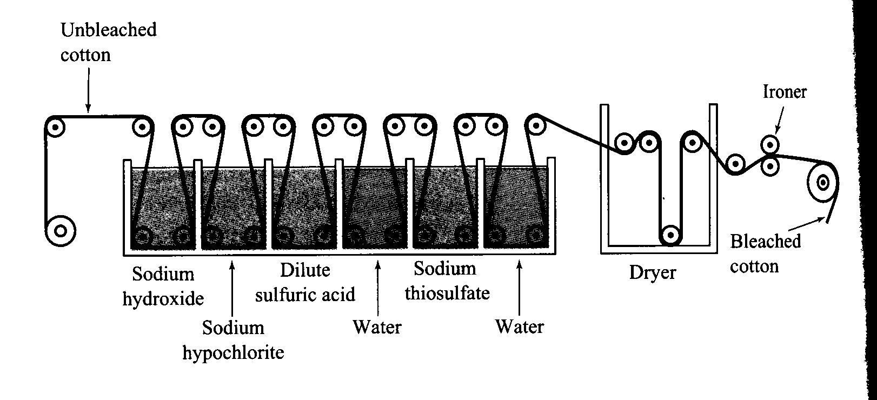
[ 6 marks]
1
2
3
6
5
4

4. The bleached fabric is washed and then treated
6. A final rinse removes all chemicals and the fabric is ready for further processing.
4. Identify by name or formula an example of each of the following.

Description | Name or Formula
A positively charged complex ion

An ion which can undergo disproportionation

A gas which forms an acidic solution in water

A primary standard suitable for redox titration

A chemical used to intensify the colour and
presence of halogens in solution.

An element that exhibits in its compounds oxidation states including +2 and +7

A salt that dissolves to give a neutral solution

[8 marks]
5. Write brief explanations for the following statements:

(a) Phenolphthalein is a good indicator for detecting the end point in a titration between a weak acid and a strong base, but not between a strong acid and a weak base.

[3 marks]

(b) Sulfuric acid is used to acidify KMnO₄ in a redox titration, whereas hydrochloric acid is not.

[3 marks]
6. (a)For the species below, draw the structural formula, representing all valence shell electron pairs
..
either as : or [ For example, water H : O : H or H O H and so on ]
..

Species | Structural formula (showing all valence shell electrons) | Shape  (sketch or name)
chlorate ion,
ClO₃⁻

carbon dioxide,
CO₂

[4 marks]

Write the electron configuration (using s, p, d notation) for the following species:

(b) S²⁻
(c) K
[2 marks]

7. Relate the following properties of ionic compounds to the ionic bonding model.
Ionic compounds are poor conductors of electricity in the solid phase

[2 marks]
8. Using the axes provided, draw sketch graphs of the following. You are not required to place any numbers on the scales. [2, 2, 2 marks]
(a) The electronegativities of the elements of group I.

Electonegativity

Li Na K Rb Cs

(b) The first six successive ionization energies of Silicon.

Successive
Ionisation
Energy

1 2 3 4 5 6
Number of ionisations

(c)
Relative acidity of the oxides of the selected elements in the 3rd row of the periodic table

Acidic

Neutral

Basic
Na Mg Si P S Cl

9. When a solution containing potassium dichromate (K₂Cr₂O₇) and sulfuric acid is added to a solution of tellurium (IV) oxide (TeO₂), the mixture turns deep green which indicates that chromium (III) ions are produced. Every reduction must be accompanied by oxidation, so the TeO₂ must have been oxidised. The only known higher oxidation state for Te is +VI, so presumably an ion similar to SO₄²⁻ is produced. Work out the equation for the overall reaction that has occurred.
Oxidation half-equation:

Reduction half-equation:

Redox equation:

[6 marks]

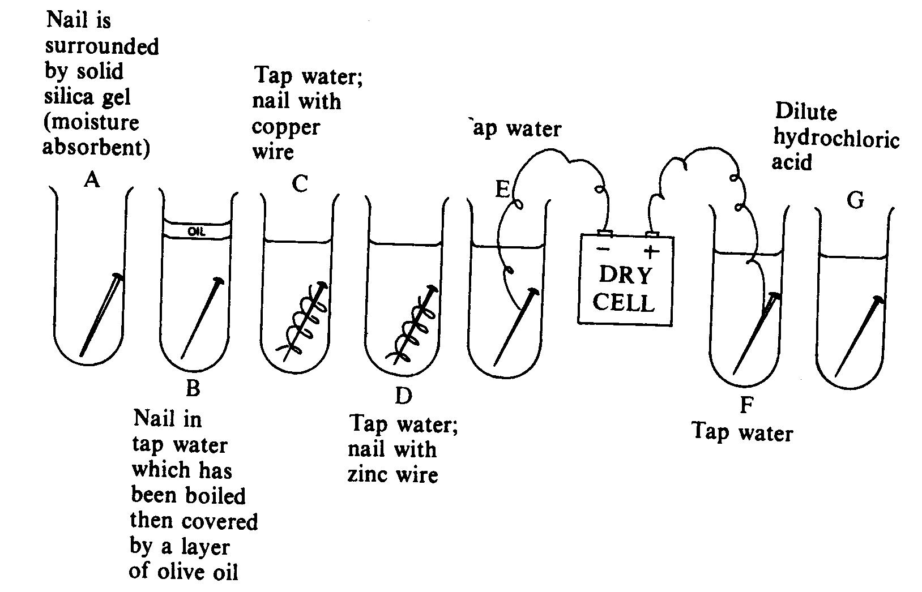
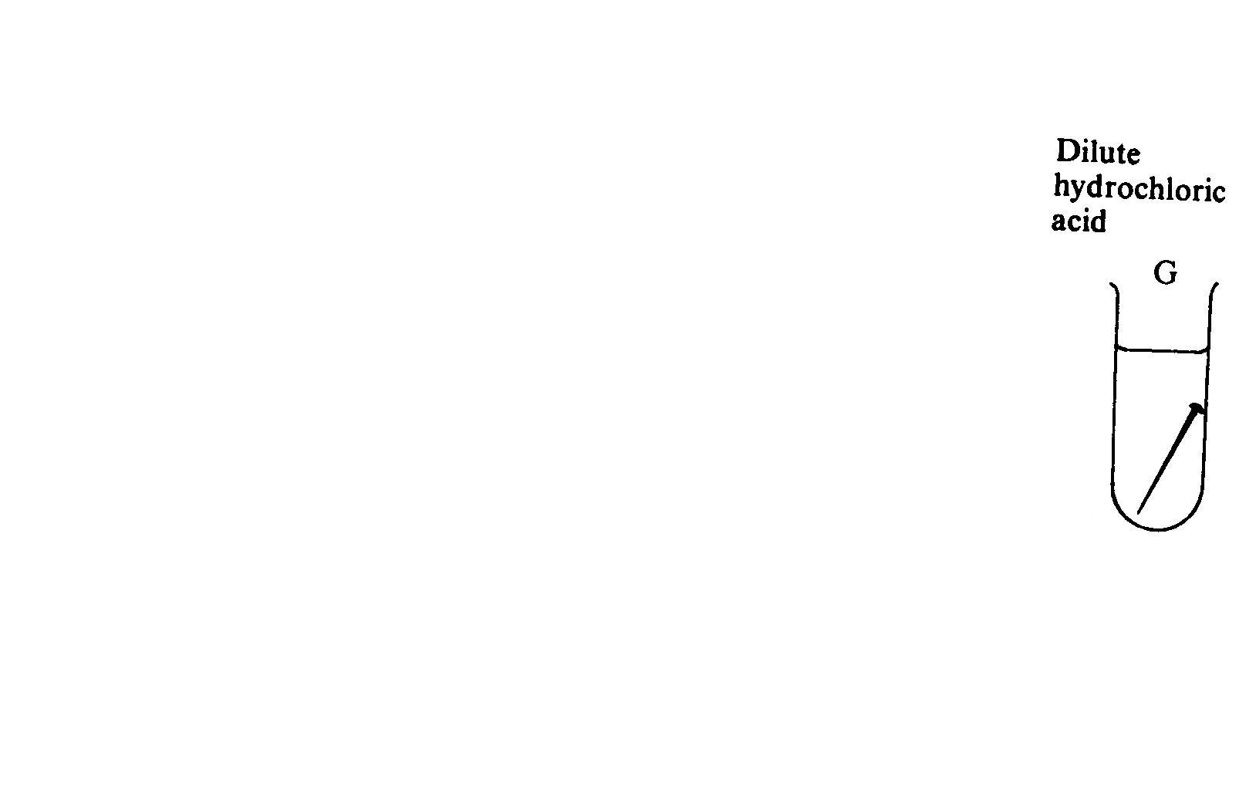
10.

Corrosion is the process by which metals are converted to oxides or other compounds. This causes the metals to gradually deteriorate as illustrated by the rusting of iron and steel in salty ocean environments.

(a) Write the equations that represent the rusting of iron.

Oxidation half-equation:

Reduction half-equation:
O_{2(g)} + 2H₂O_{(l)} + 4e → 4OH⁻_{(aq)}

Redox equation:

[2 marks]

- In tubes A, B and D no evidence of corrosion of the nail or rust formation was found after one week. However in tube C the nail was deeply corroded and rust was present while in G the nail was very corroded but no rust was visible. On the basis of the redox equation and your knowledge of metals, briefly explain:

(i) the absence of corrosion and rust in B

[2 marks]

(ii) why there is corrosion but no rust in G

[1 mark]

END OF PART 2
PART 3 (50 marks)

Answer ALL questions in Part 3. The calculations are to be set out in detail in this
Question/Answer Booklet. Marks will be allocated for correct equations and clear setting out,
even if you cannot complete the problem. When questions are divided into sections, clearly
distinguish each section using (a), (b), and so on. Express your final numerical answers to three
(3) significant figures where appropriate, and provide units where applicable. Information which
may be necessary for solving the problems is located on the separate Chemistry Data Sheet.
Show clear reasoning: if you don't you will lose marks.

1. 1. Naturally occurring calcite is crystalline calcium carbonate. 25.00 mL of dilute hydrochloric acid was added to 0.6342 g of calcite. The mixture was gently boiled.

(a) Write the equation for reaction that occurs. [2 marks]

The unreacted solid was filtered and washed. It was then dried at 120°C to a constant weight of 0.392 g.

(b) Calculate the concentration of the hydrochloric acid. [4 marks]

2. A hydrated compound had the empirical formula Fe_{x}(CO)_{y}.zH₂O.
A 5.319 g sample of this compound was heated at 120°C for an hour and weighed.
It was found to have a mass of 4.030 g. It was then heated for a further 30 minutes and, when weighed, was found to have a mass of 4.029 g.

The residual compound was then burnt in pure oxygen to produce 1.914 g of Fe₂O₃ and
4.214 g of carbon dioxide. No water was produced.

(a) Determine the values of x, y and z. [9 marks]

(b) Why was the compound weighed twice during the initial heating? [1 mark]

3. In a test to determine the level of alcohol in the blood of a motorist, 5.00 mL of blood was added to 100.0 mL of 0.005961 mol L⁻¹ acidified potassium dichromate solution.
The mixture was heated to 70°C for four hours so that all of the ethanol in the blood sample was oxidised to ethanoic acid. This reaction can be represented by the following equation:

3 CH₃CH₂ OH + 2 Cr₂O₇²⁻ + 16 H⁺ → 3 CH₃COOH + 4 Cr³⁺ + 11 H₂O
Ethanol Ethanoic acid

The volume of the mixture was made up to 150.0 mL by the addition of distilled water.

A titration was then done to find out the amount of potassium dichromate left after the reaction. 30.00 mL samples of the reaction mixture were titrated against a 0.04104 mol L⁻¹ solution of iron(II)sulfate.

(a) Write an equation for the reaction between potassium dichromate solution and the iron(II)sulfate solution. [2 marks]

(b) The following titration results were obtained. Complete the table. [1 mark]

 | 1 | 2 | 3 | 4
Final Volume (mL) | 17.56 | 33.50 | 18.53 | 34.43
Initial Volume (mL) | 0.50 | 17.56 | 2.55 | 18.53
Titre

(c) Calculate the concentration of ethanol in the blood in [8 marks]
(i) mol L⁻¹
(ii) g L⁻¹

(d) The legal limit for ethanol in the blood is 50 mg per 100 mL of blood. Was this blood sample under or over the limit? (You must show reasoning.) [2 marks]

4 A damp mixture of potassium iodide and potassium sulfate was dissolved in water and made up to 250.00 mL. 25.00 mL of this solution was treated with an excess of barium nitrate until no further precipitate formed. The solid was filtered and washed. It was then dried to a constant weight of 0.218 g.

(a) Write the equation for the reaction that produced the precipitate. [1 mark]

(b) Calculate the mass of the compound in the damp mixture that produced the precipitate.
[3 marks]

A second 25.00 mL sample of the solution was treated with an excess of lead nitrate solution until no further precipitate formed. The solid was filtered and washed. It was then dried to a constant weight of 0.607 g.

(c) Write the equation for the equations the two reactions that produced the precipitate. [2 marks]

(d) Calculate the mass of the second compound in the damp mixture. [4 marks]

5. The following equation describes the reaction between sulfur tetrafluoride and diiodine pentaoxide:

5 SF_{4 (g)} + 2 I₂O_{5 (s)} → 4 IF_{5 (l)} + 5 SO_{2 (g)}

32.07 g of I₂O₅ is shaken with 6.02 L of SF₄ at 76°C and 120 kPa, and the reaction allowed to go to completion.

(a) Find the limiting reagent.(Show all reasoning.) [2 marks]

(b) Find the number of moles of SO₂ and hence the volume of SO₂ actually produced. [ 3 marks]

(c) Find the mass of each of the substances (reactants and products) is present at the completion of the reaction? [6 marks]

PART 4 (20 marks)

Answer ONE of the following two extended answer questions.
Marks are awarded for the relevant chemical content of your answer, and also for coherence and clarity of expression. Where applicable, use equations, diagrams and illustrative examples of the chemistry you are describing.

Your answer should be presented in about 1.5 to 2 pages. Commence your answer on page 32.

1. The extraction of metals from their ores and their subsequent refining or
purification is of vital importance in today's economy.
Discuss the steps involved in the extraction through to the refining of gold using appropriate chemical reactions and detailed explanations.

[20 marks]

OR

2. One of the most important techniques in analytical chemistry is volumetric analysis where titrations are used to find the concentrations of unknown solutions. Much care has to be exercised as the amounts of active reagents are generally extremely small.
Choose ONE of the following titration examples and use it to describe the experimental techniques used in a typical volumetric titration.

- Finding the percentage of iron in steel wire.
- Finding the amount of ethanoic acid in vinegar.

Set out your answer using the following sub-headings:
Cleaning glassware.
Steps and techniques used.
List of calculation steps used to work out your answer – there is no need to use any numerical data.
[20 marks]

END OF PAPER

